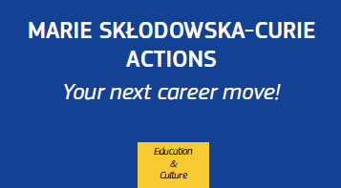

**Marie Skłodowska-Curie Actions (MSCA)**

**Research and Innovation Staff Exchange (RISE)**

**An Opportunity to Build International Partnerships with European Research Institutions and Companies**

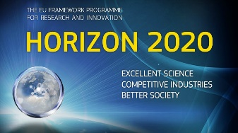

**CALL OPEN – Closing date is 28 April, 2016**

***What Is the MSCA Research and Innovation Staff Exchange (MSCA-RISE)***

RISE is one of the Marie Skłodowska-Curie Actions (MSCA) under Horizon 2020, the European Framework Program for Research and Innovation.

***What is the aim of MSCA-RISE?***

MSCA-RISE aims at international and inter-sector collaboration through promoting research and innovation exchanges of staff. MSCA-RISE will support short-term mobility of research and innovation staff at all career levels, from the most junior (post-graduate) to the most senior (management), including administrative and technical staff.

***Who can apply?***

MSCA-RISE is open to partnerships of universities, research institutions, and non-academic organisations both within and beyond Europe. Universities, research institutes can apply, not individuals. ASEAN universities, research institutes, and companies are eligible.

***Why should I apply?***

You can expand and strengthen your network and gain new expertise. You and your European partners can share knowledge and skills, and broaden the career development of your staff, and you can strengthen your institutional links with Europe.

***Which research topics are supported?***

Any research field may qualify for MSCA-RISE funding, apart from areas covered by the EURATOM Treaty.

***How does it work?***

An MSCA-RISE partnership is composed of at least three independent participants established in three different countries. An ASEAN university, research institute or company would need to partner with organisation in *at least* 2 European countries to propose a joint research and innovation project. Proposals should highlight networking opportunities, sharing of knowledge and the skills development of staff members.

***What does the funding cover?***

The funding covers secondments of staff members from one month to one year as well as funding to support research, training and networking activities. Funding for an MSCA-RISE project can last up to four years.

***How can I apply?***

Inform yourself about the application timeline and familiarise yourself with the most important documents (Guide for Applicants and Work Programme). For questions, please contact [simon.grimley@euraxess.net](mailto:asean@euraxess.net)

***When can I apply?***

The MSCA-RISE-2016 call for proposals opened on 8 December 2015 with a deadline of 28 April 2016.

***More information*** [***here***](http://ec.europa.eu/research/participants/portal/desktop/en/opportunities/h2020/topics/2117-msca-rise-2016.html) ***and*** [***here***](http://ec.europa.eu/research/mariecurieactions/about-msca/actions/rise/index_en.htm)

